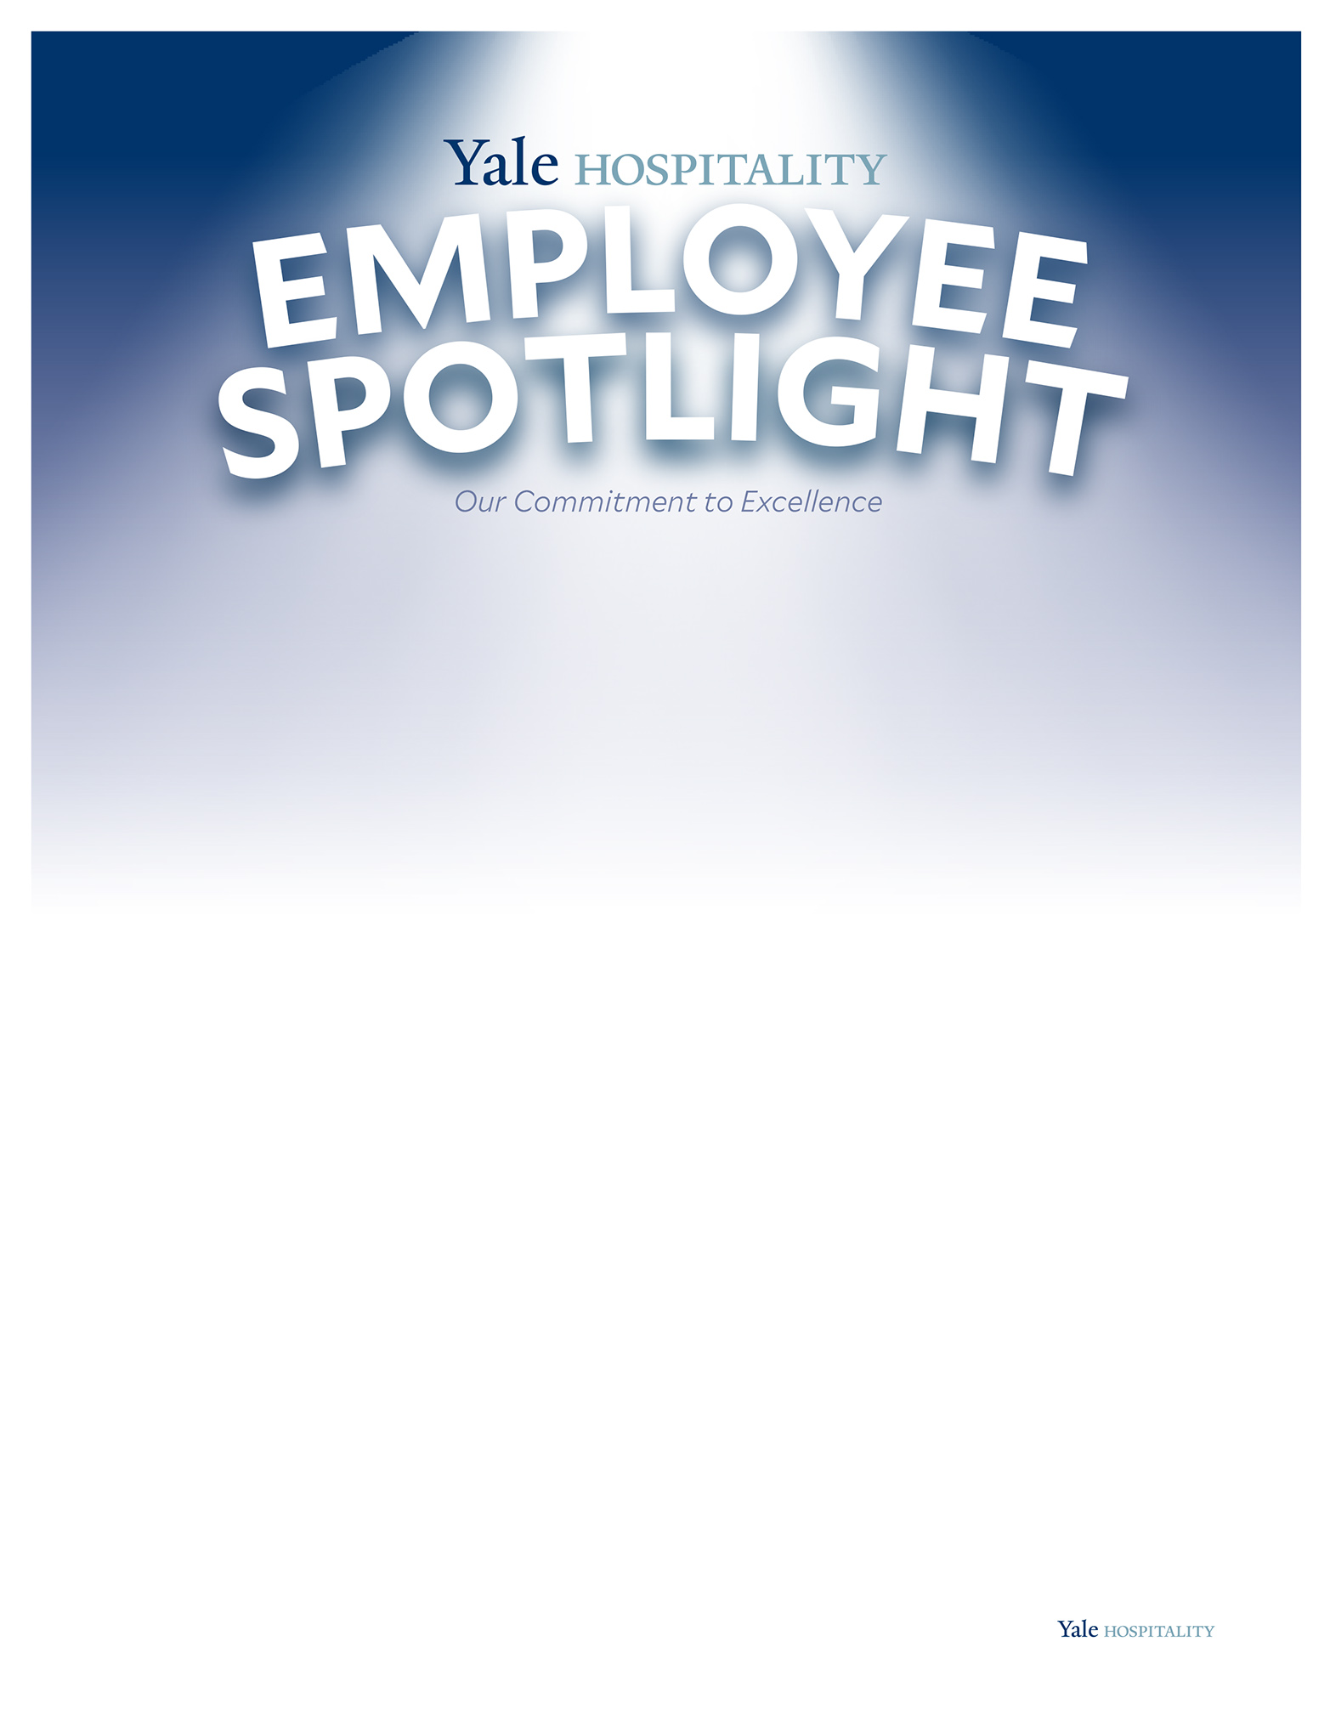


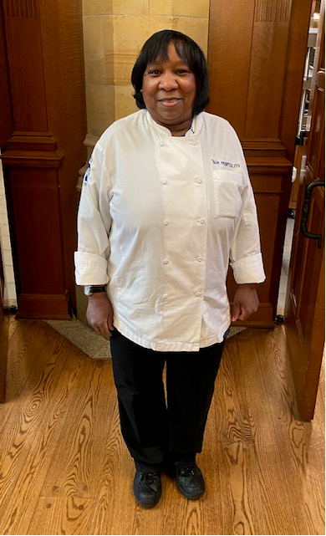
Jimmie Moore has worked for Yale Hospitality for nearly
20 years (including as a GSA for 15)! Biggs, as his fellow
coworkers affectionately call him (GSA nicknames are a
badge of honor amongst the staff), is truly a pillar of the
Branford and Saybrook Dining Team. He is seen as a lead
Staff member, and brings a level of positivity and care for
his team to his work- he is an advocate for the staff.

Jimmie grew up in New Haven two blocks from the University! ‘It honestly feels like home’, he states. Jimmie used to run and play on campus as a kid, and is thankful for the Big Brother/Big Sister program that he was mentored in (by students from Yale). He said he knew as a young person that Yale was a really special place to be, and is honored to be a part of it now. Working at Yale really gives Jimmie a sense of purpose. He shared that he went from someone with no real direction, working 3 menial jobs, to someone who loves his job, his environment, and the people he meets every day. “My job makes me feel alive!”. He is proud to have built a strong bond with his work family, and appreciates the opportunities to make people smile.

Speaking of family, Jimmie comes from a very large family, and that’s why he enjoys working alongside so many others. Jimmie has 2 sisters who have worked for the university, as well. He is proud of how his family has accomplished so much, while staying so humble. His grandparents relocated to New Haven from NC and really ‘made it on their own.’ These values are instilled in his parents and his siblings, not to mention his 3 children (1 daughter and 2 sons), who are all college-bound. “My family can be crazy, but it comes from a place of love, and we are always there for each other.” Jimmie cares about his community, being involved in initiatives
to protect the rights of other members, including restoring Ashmund St. Park.

Jimmie shares some advice for the Yale Class of ’22- “Strive for the best! Don’t
let anyone tell you that you can’t achieve your goals. Always be prepared for
what may come, but never lose focus of the here and now.”
Jimmie Moore
General Services Assistant
