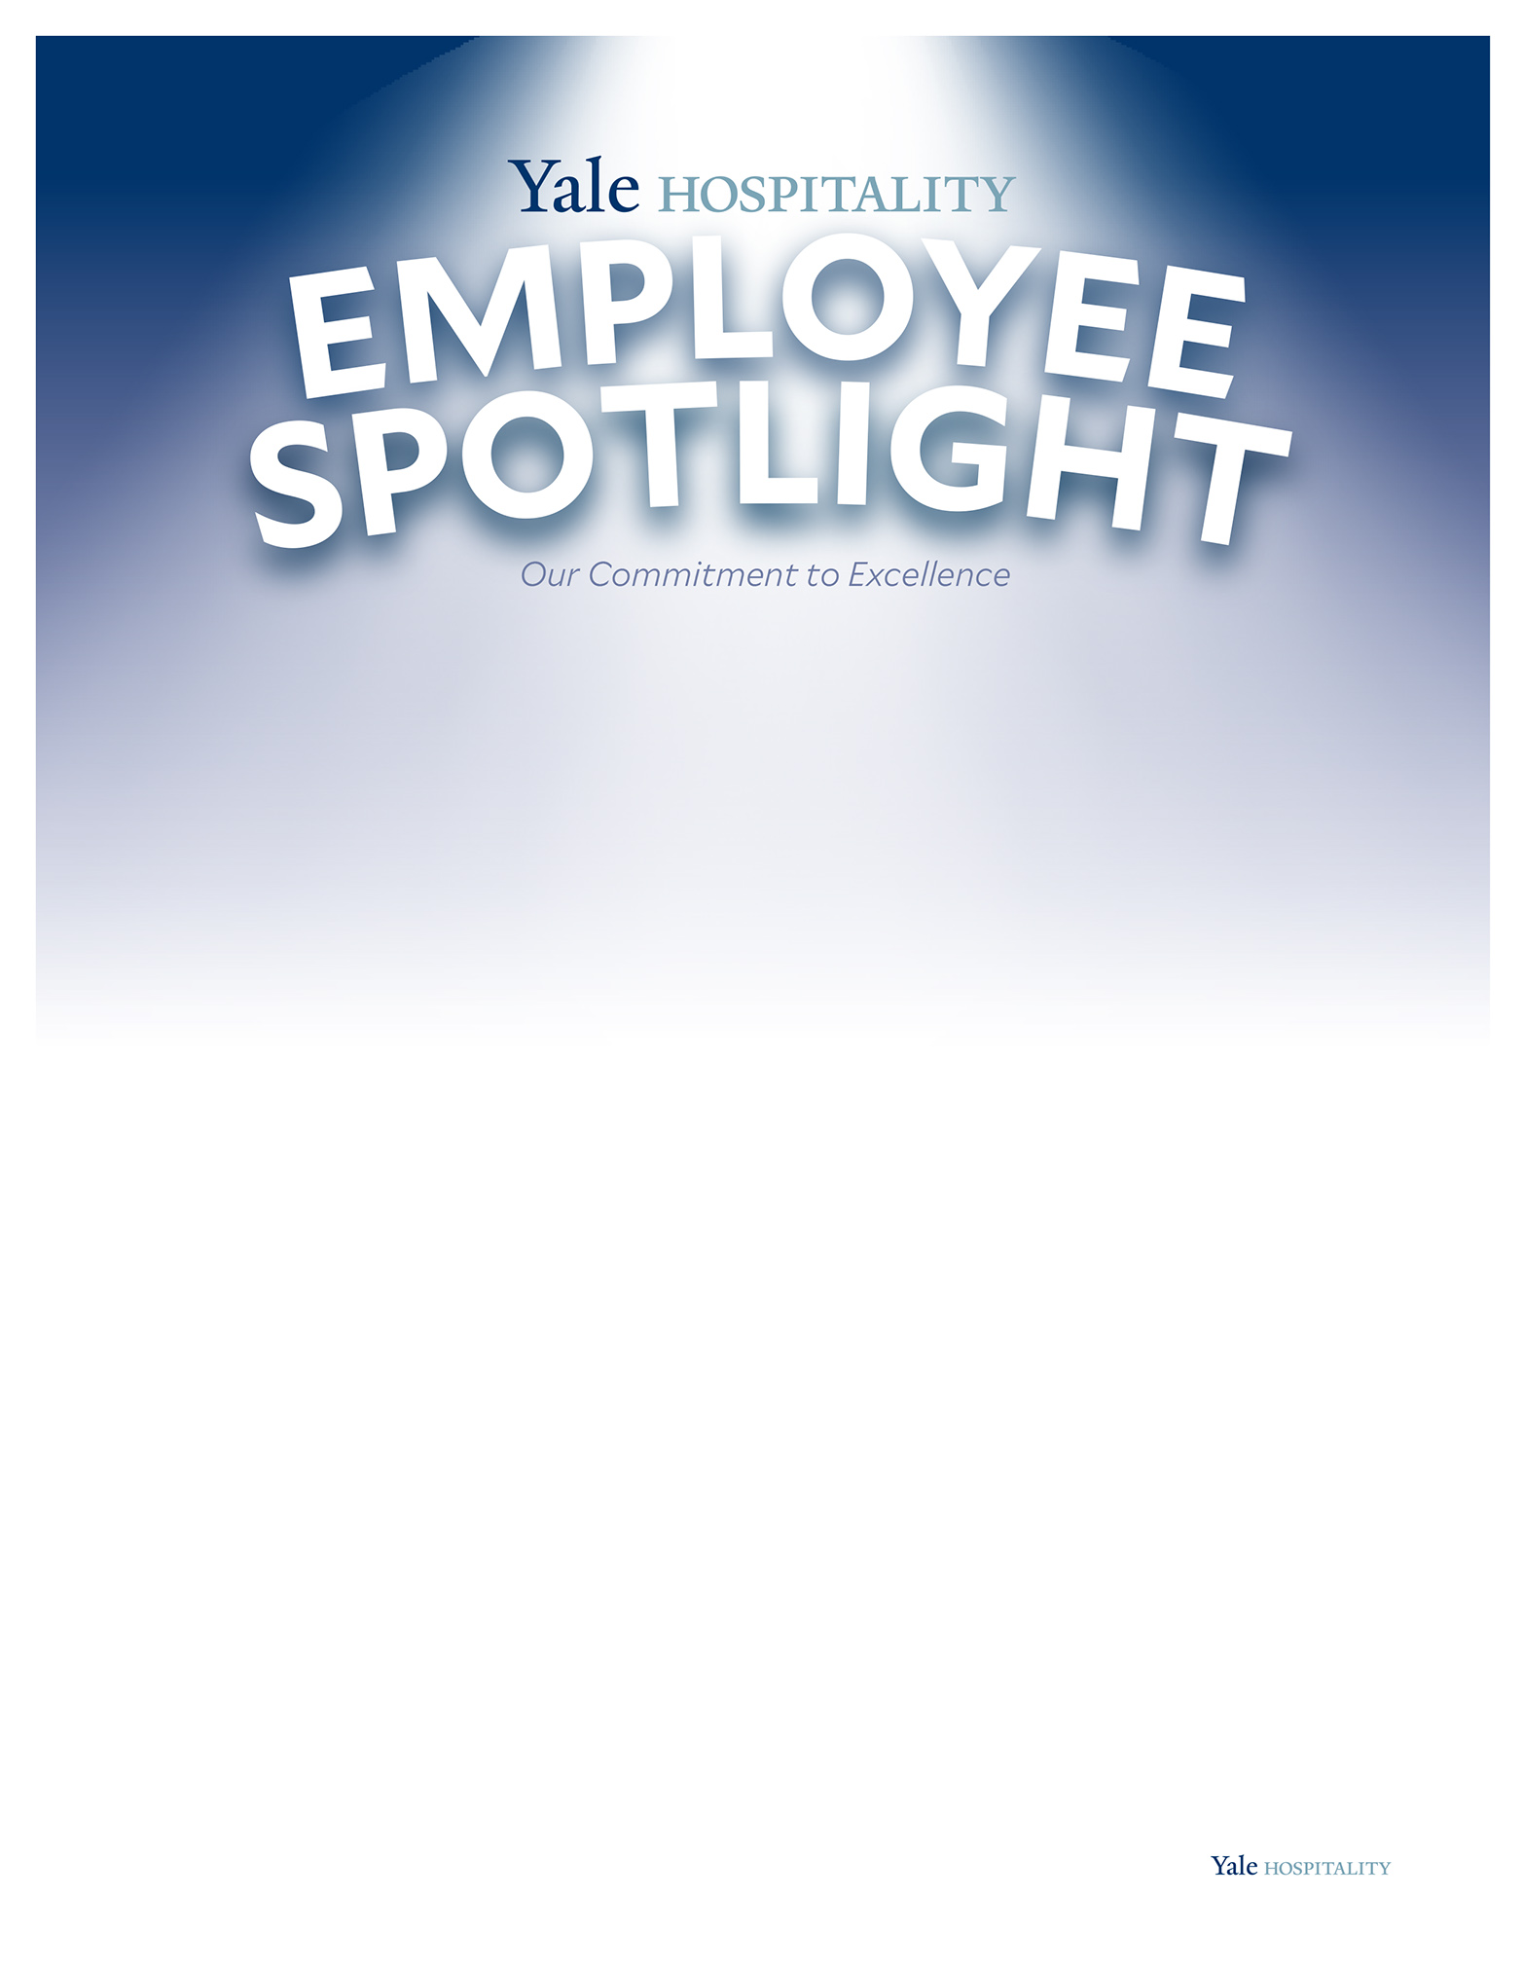
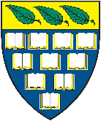
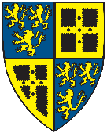
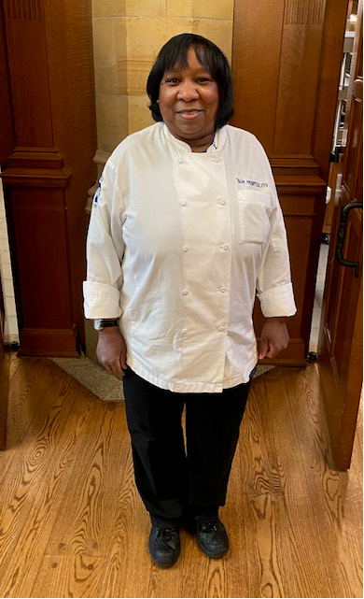
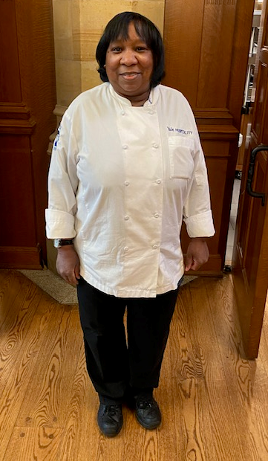
Linda Felder has worked for Yale Hospitality for over
37 years (starting January 13, 1985)! Fun Fact- Linda
was a member of the Hospitality family in each of the
last five decades! Meeting so many wonderful students
is her favorite part about working here, many of which
continue to ask about her years later when they come
back to visit. She never forgets a face.

Linda grew up in New Haven with her parents and 9 siblings (5 boys, 5 girls)! Four of her brothers (Bill, Alan, Larry, and Bruce) have worked for Yale between 30 and 46 years. Her nephew, Brandon, has been with the team for nearly a decade himself. Even Linda’s parents, who moved to New Haven in 1953, have worked for the University. Her father was a 1st Cook and once prepared a meal for John F Kennedy right here on campus. Her mother worked in Custodial at the Medical School for 21 years. For Linda, Yale (especially Yale Hospitality), truly is a family affair.

Linda loves to knit and crochet, and can often be found doing so outside during her break on a nice day. Linda has made over 300 unique gifts for friends and family, given out during holidays such as Christmas, Valentine’s Day, and Mother’s Day, among others. Linda has also made hats to be given to charity. This is important to Linda- giving back to her community.

Linda wishes the Yale Class of ’22 Good Luck and the Best in their Endeavors!
Favorite Yale Meal:
“I really enjoyed the Black History Dinner with Jamaican-themed
cuisine we had last week at Branford and Saybrook.”

All-Time Favorite Dish:
Fettucine Alfredo is a favorite, or Steak and Lobster for a special treat!

Linda Felder
Desk Attendant

